Level 6 -> Level 7

The goal of this level is to find the pass to log into <http://natas7.natas.labs.overthewire.org>.

Username: natas7

After logging into level 6 we got a hint to get the password of next level. **There is a link to view the source code.** So, simply click on the link to view page source.

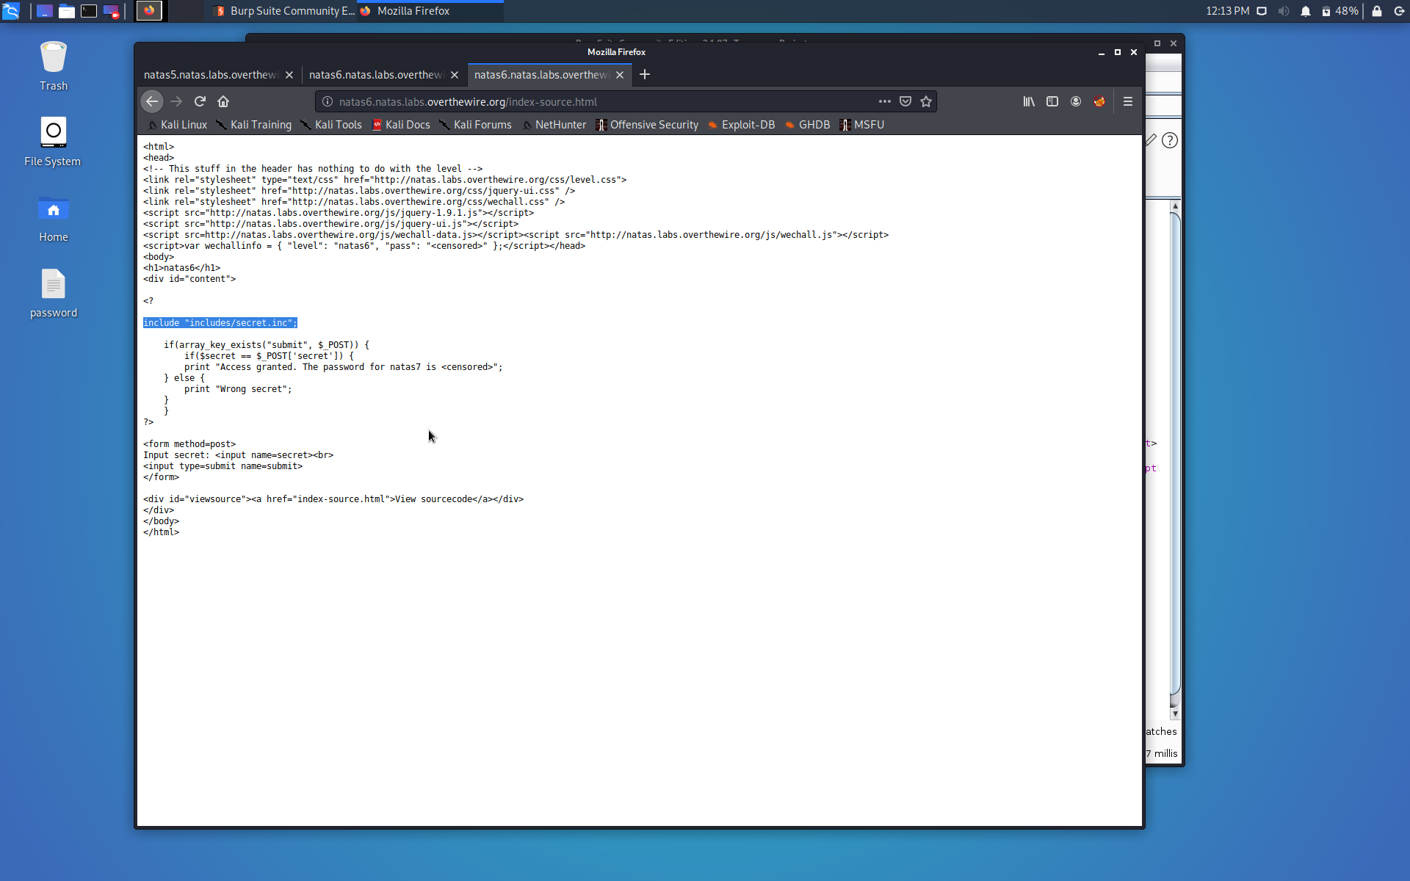

It includes a secret to get the password to the next level. The secret we enter should match the secret that is present at **includes/secret.inc**

So, visit <http://natas6.natas.labs.overthewire.org/includes/secret.inc> . But a blank page is displayed. Navigate to the page source.

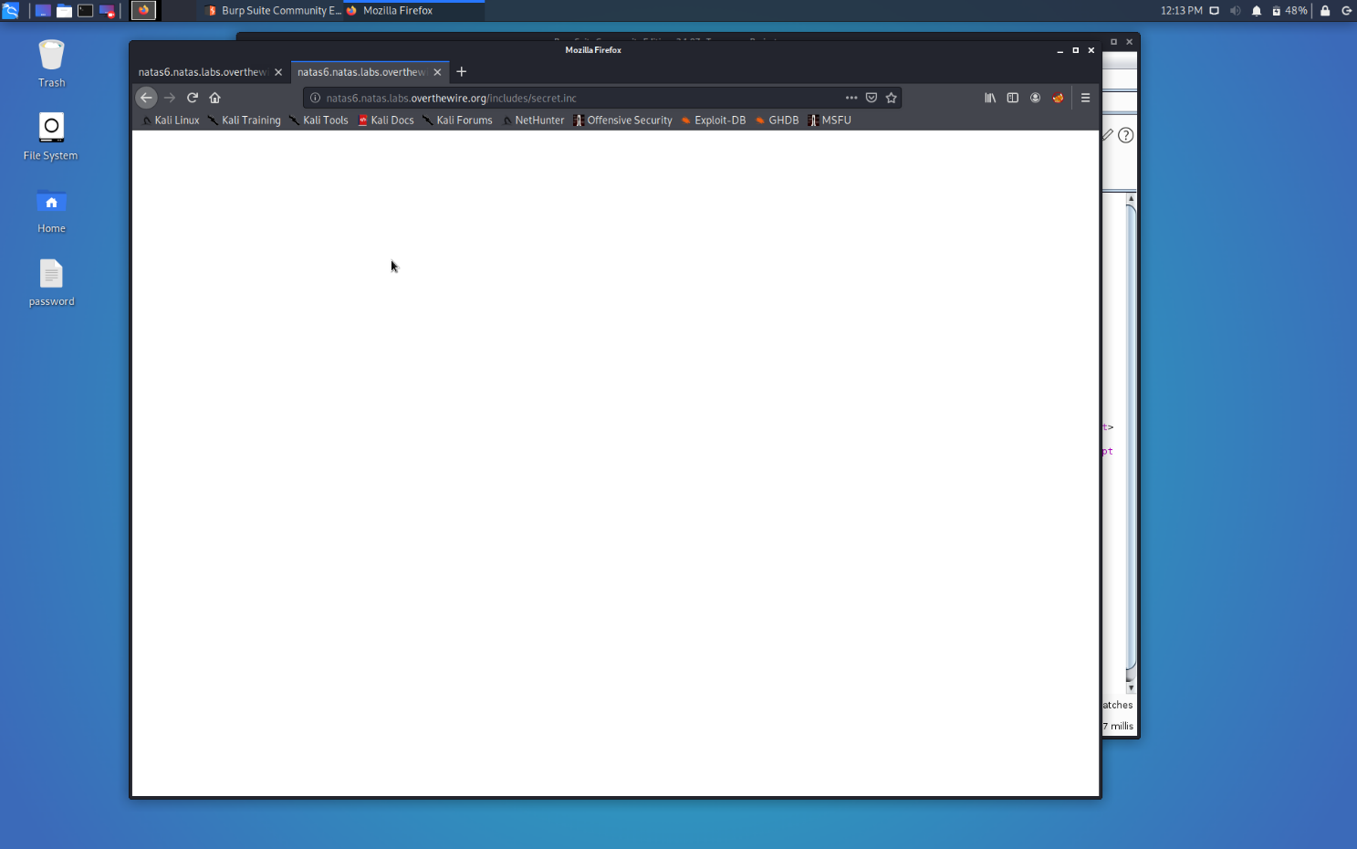

And here, we got the secret that we need to enter.

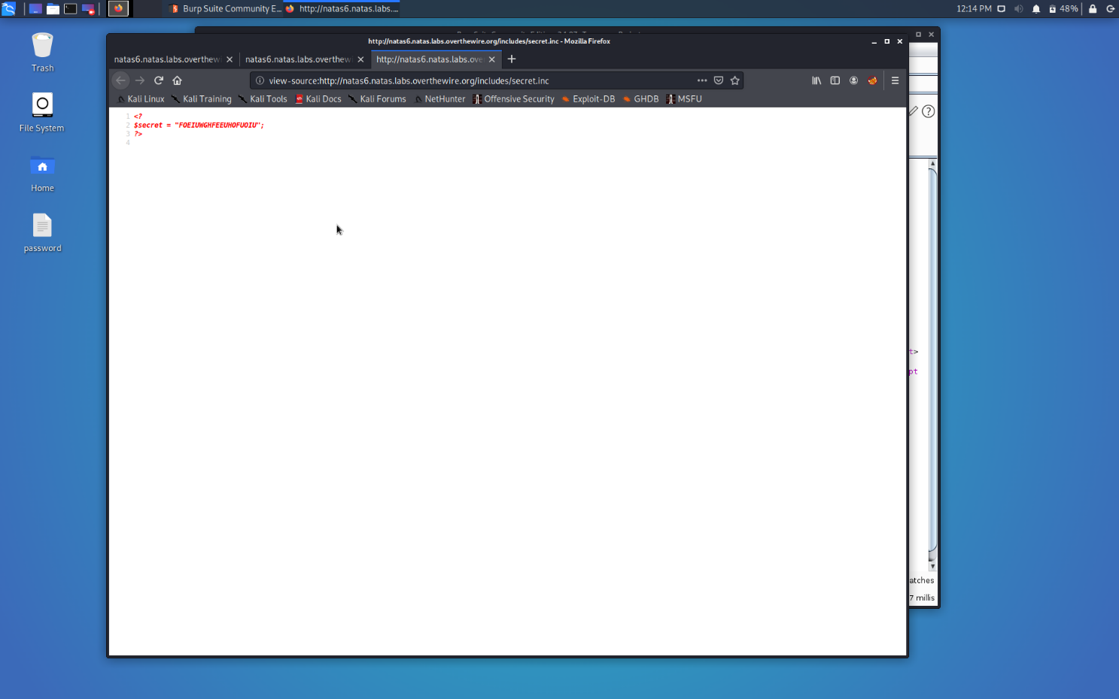

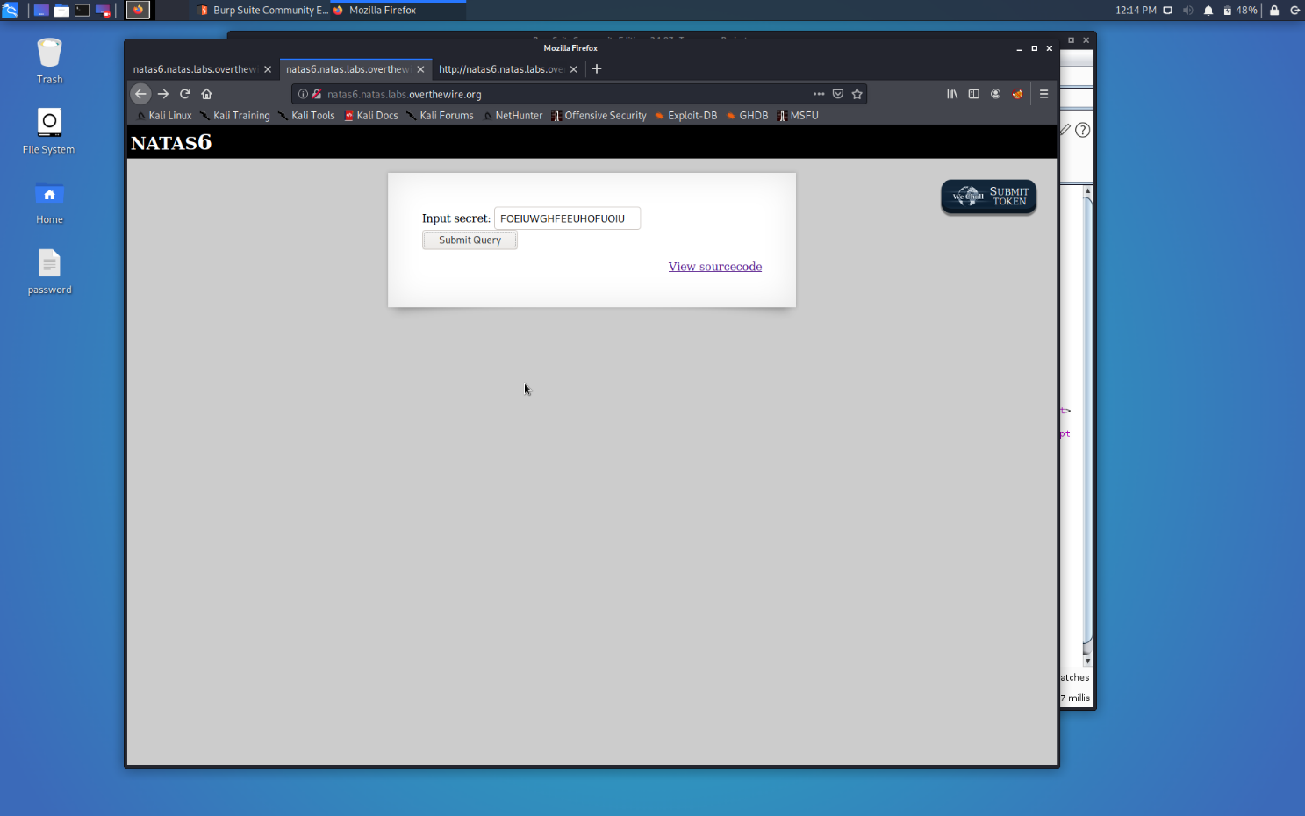

And here is the password to natas7…

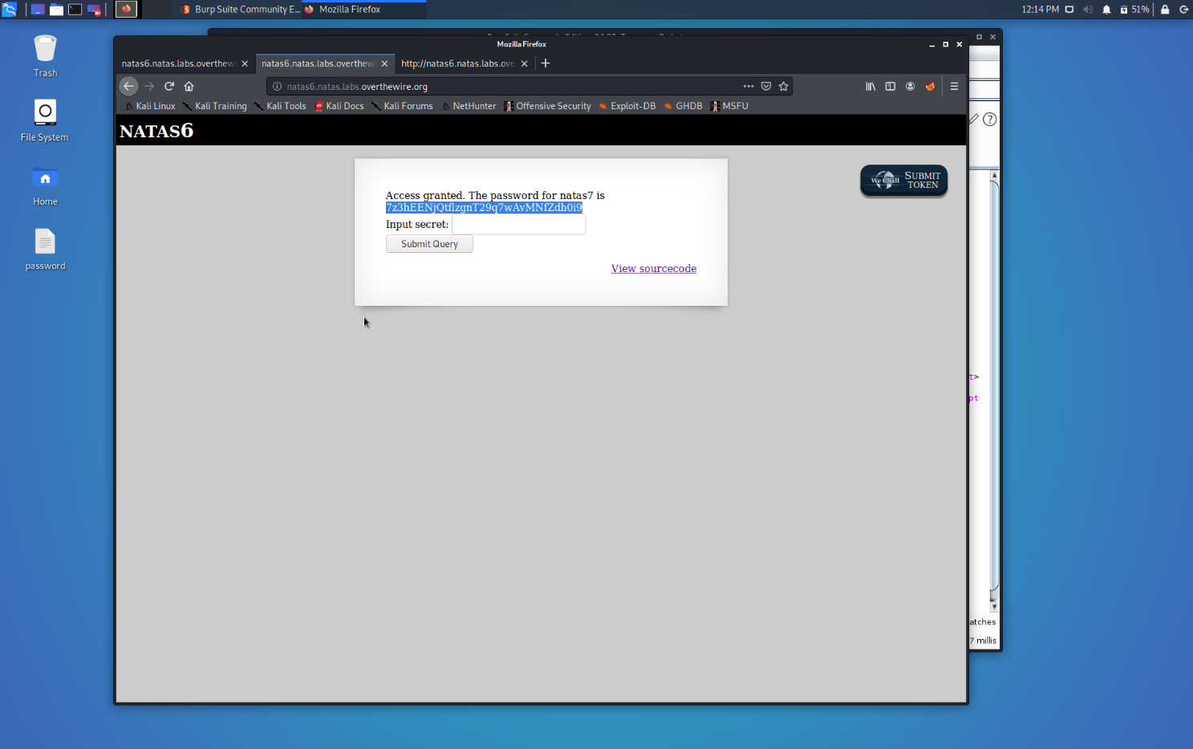

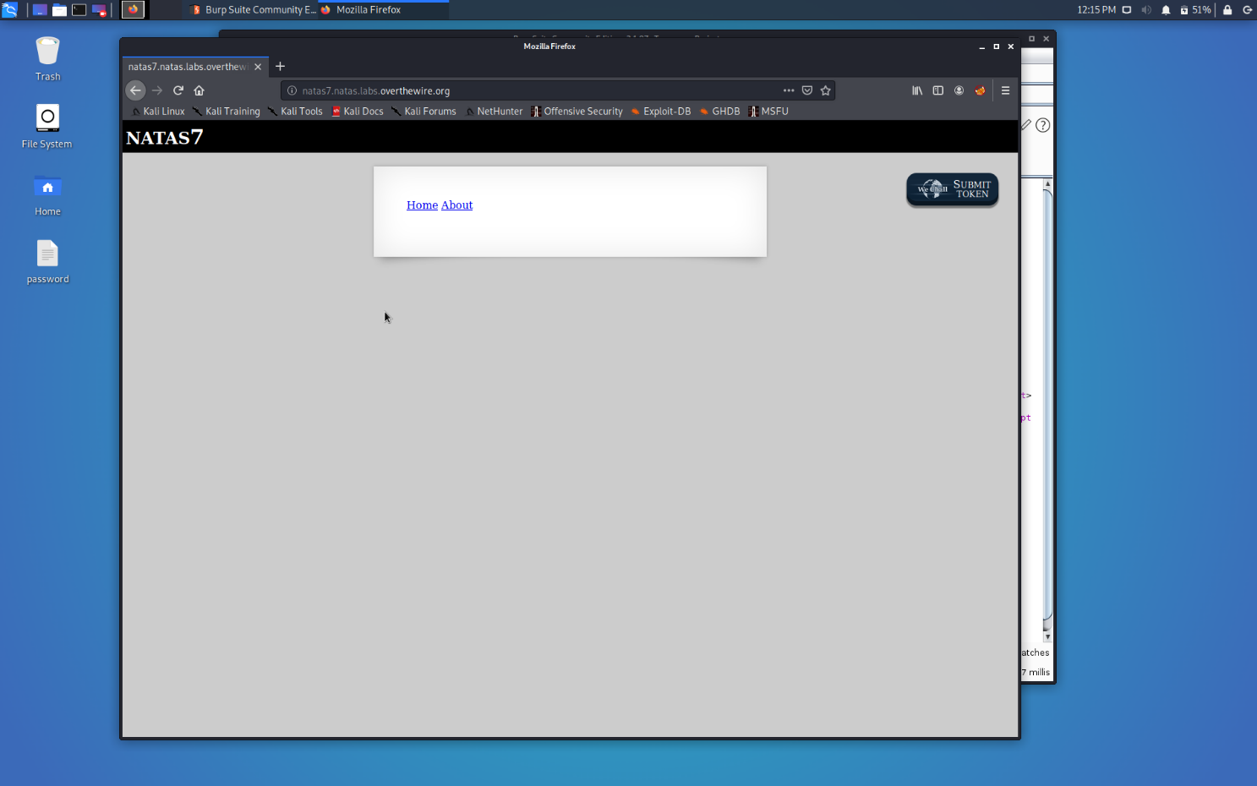

Successfully passed level 7.…